1

|  |  |  |
| --- | --- | --- |
|  | **VILLA ROMA BOTIQUE HOTEL**  5 Bethal street  Modelpark  1034 | E:\college logo2.jpg |

**Enq: O Tau**

**🕿 : 013 656 1750**

**Cell: 081 5600 757**

**Email:** [**tau.o@nkangalafet.edu.za**](mailto:tau.o@nkangalafet.edu.za)

**Training Manual: Handle and Dispose of Waste at Villa Roma Boutique Hotel**

**Table of Contents: Handle and Dispose of Waste at Villa Roma Boutique Hotel**

1. **Introduction**
   * Purpose of the Manual
   * Overview of Waste Management at Villa Roma Boutique Hotel
2. **Module 1: Understanding Waste and Its Impact on the Environment**
   * Learning Outcomes
   * What is Waste?
   * Categories of Waste
   * Effects of Waste on the Environment
   * Exercise: Categorizing Waste at Villa Roma Boutique Hotel
   * Self-Assessment Task
   * Conclusion
3. **Module 2: Principles of Waste Management**
   * Learning Outcomes
   * The Waste Management Hierarchy
   * Application of the Waste Hierarchy at Villa Roma Boutique Hotel
   * Exercise: Applying the Waste Hierarchy
   * Self-Assessment Task
   * Conclusion
4. **Module 3: The Waste Management Process**
   * Learning Outcomes
   * Steps in the Waste Management Process
   * Waste Generation, Storage, Collection, and Transport
   * Waste Treatment and Disposal Methods
   * Waste Tracking Documentation
   * Exercise: Mapping the Waste Management Process
   * Self-Assessment Task
   * Conclusion
5. **Module 4: Recognizing and Responding to Special Waste**
   * Learning Outcomes
   * Types of Special Waste
   * Responding to Special Waste
   * Emergency Procedures for Special Waste
   * Exercise: Handling Special Waste at Villa Roma Boutique Hotel
   * Self-Assessment Task
   * Conclusion
6. **Module 5: Applying Waste Management Principles and Procedures in Your Own Context**
   * Learning Outcomes
   * Minimizing Waste
   * Reusing Materials
   * Recycling
   * Handling and Disposal
   * Investigating a Waste Stream
   * Exercise: Practical Waste Management Solutions
   * Self-Assessment Task
   * Conclusion
7. **Wrap-Up**
   * Final Thoughts on Waste Management
   * The Importance of Environmental Responsibility
   * Commitment to Sustainability at Villa Roma Boutique Hotel

**Module 1: Understanding Waste and Its Impact on the Environment**

**Purpose of the Module:** By completing this module, you will be able to identify different categories of waste, understand how waste interrelates with the environment, and describe both the negative and positive effects of waste on the environment.

**Learning Outcomes (LOs):**

**LO 1.1:**

**Name and describe different categories of waste.***Assessment Criteria Range:* General waste, hazardous waste, biodegradable waste, recoverable waste, etc.

**LO 1.2:**

**Describe the adverse and potentially beneficial effects of waste on the environment.***Assessment Criteria:* Provide descriptions of the harmful impacts (pollution, habitat destruction) and beneficial effects (composting, recycling) of waste on the environment.

**Content:**

**What is Waste?**

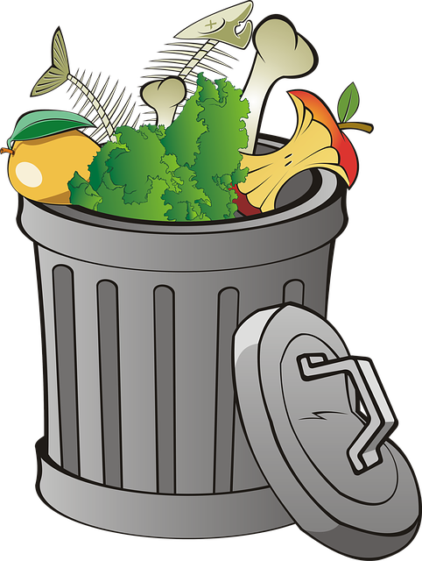

[**https://pixabay.com/illustrations/trash-waste-recycling-recyclable-3323974/**](https://pixabay.com/illustrations/trash-waste-recycling-recyclable-3323974/)

[**https://cdn.pixabay.com/photo/2018/04/16/09/12/trash-3323974_1280.png**](https://cdn.pixabay.com/photo/2018/04/16/09/12/trash-3323974_1280.png)

**Painter06**

Waste is any material that is no longer needed, used, or deemed as having no value. In the hotel industry, waste can come in many forms and has different impacts on the environment if not managed properly.

**Categories of Waste:**

* **General Waste:** Non-hazardous waste like packaging materials, paper, and food waste.

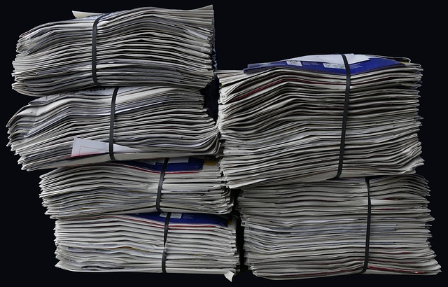

<https://cdn.pixabay.com/photo/2017/08/05/23/27/newspapers-2586621>

<https://cdn.pixabay.com/photo/2017/08/05/23/27/newspapers-2586624_1280.jpg>

anaterate

* **Hazardous Waste:** Waste that is harmful to human health or the environment, such as chemicals and cleaning agents.

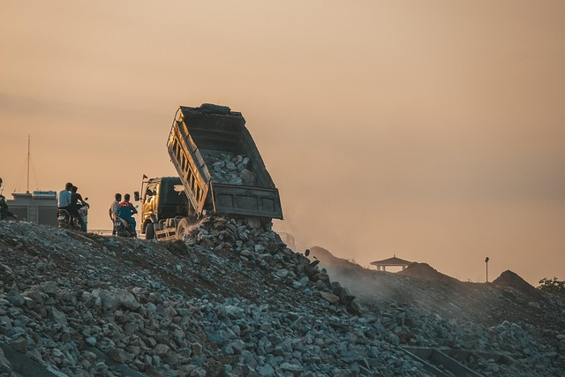

<https://cdn.pixabay.com/photo/2020/07/13/13/20/garbage-5400780_640.jpg>

<https://pixabay.com/photos/garbage-landfill-truck-dump-truck-5400780/>

**khoinguyenfoto**

* **Biodegradable Waste:** Organic waste that can decompose naturally, including food scraps and garden waste.

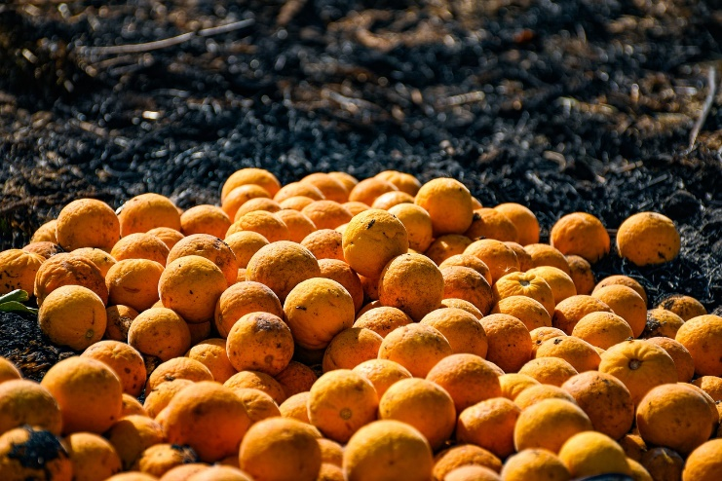

<https://pixabay.com/photos/fruit-orange-citrus-waste-dump-5030091/>

<https://cdn.pixabay.com/photo/2020/04/11/11/46/fruit-5030091_1280.jpg>

**JuanMarcelFrancia**

* **Recoverable Waste:** Materials that can be recovered for recycling, such as glass, plastic, and metals.

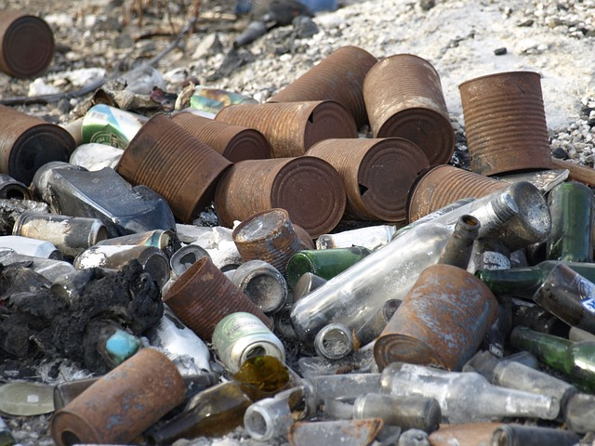

<https://cdn.pixabay.com/photo/2014/04/25/16/04/garbage-331929_640.jpg>

<https://pixabay.com/photos/garbage-scrap-metal-waste-331929/>

grafic-vision

**Effects of Waste on the Environment:**

* **Adverse Effects:**
  + **Pollution:** Improper disposal can lead to air, water, and soil pollution.

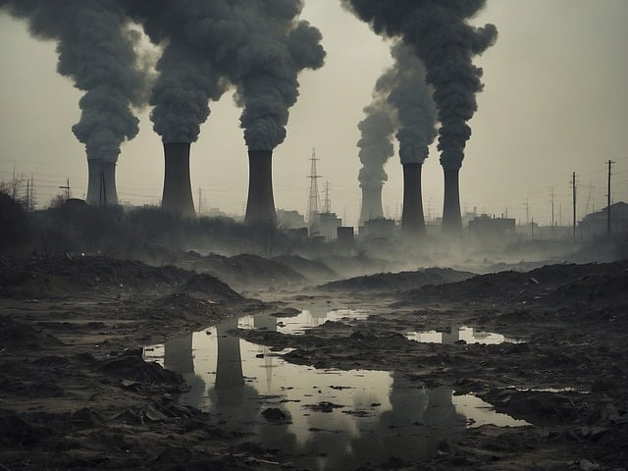

<https://cdn.pixabay.com/photo/2023/11/17/14/48/ai-generated-8394491_640.jpg>

<https://pixabay.com/illustrations/ai-generated-pollution-landfill-8394491/>

**TheDigitalArtist**

* + **Habitat Destruction:** Waste dumped in natural habitats can destroy ecosystems.

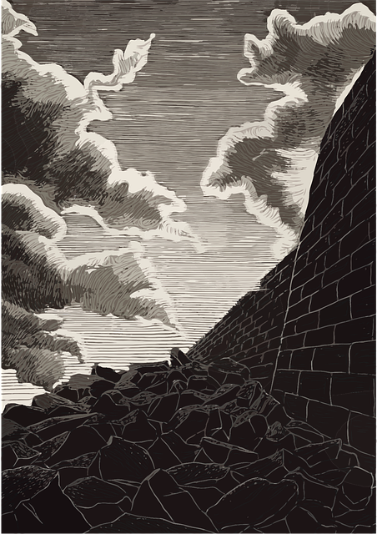

<https://pixabay.com/vectors/wall-destruction-stones-castle-7112476/>

<https://cdn.pixabay.com/photo/2022/04/04/22/41/wall-7112476_640.png>

**FreeFunArt**

* + **Health Hazards:** Accumulation of waste attracts pests and may cause disease.

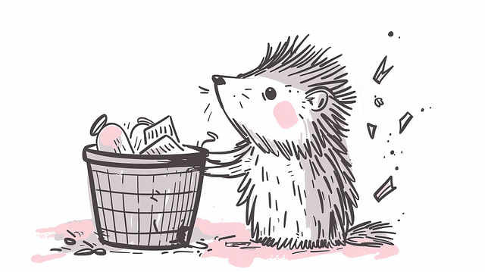

<https://pixabay.com/illustrations/ai-generated-hedgehog-beaver-8741013/>

<https://cdn.pixabay.com/photo/2024/05/05/11/27/ai-generated-8741013_1280.png>

Alexandra_Koch

* **Beneficial Effects:**
  + **Composting:** Biodegradable waste can be turned into compost to enrich soil.

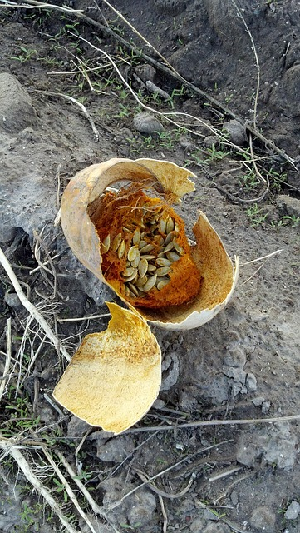

<https://pixabay.com/photos/pumpkin-rotten-dried-vegetables-72693/>

<https://cdn.pixabay.com/photo/2012/12/27/19/39/pumpkin-72693_640.jpg>

[**PublicDomainPictures**](https://pixabay.com/users/publicdomainpictures-14/)

* + **Recycling:** Reusing and processing materials reduces the need for raw materials and helps conserve natural resources.

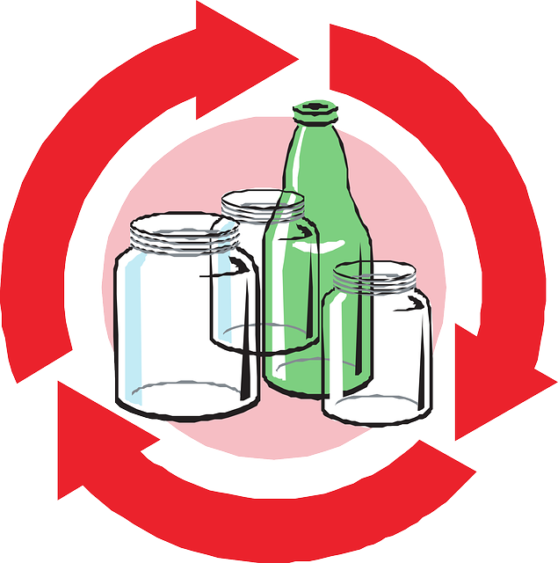

<https://pixabay.com/vectors/recycle-recycling-glass-environment-44111/>

<https://cdn.pixabay.com/photo/2012/04/28/19/14/recycle-44111_640.png>

**Clker-Free-Vector-Images**

**Exercise:**

**Categorizing Waste at Villa Roma Boutique Hotel**Below are some examples of waste. Identify the category they belong to:

1. Leftover food from the kitchen.

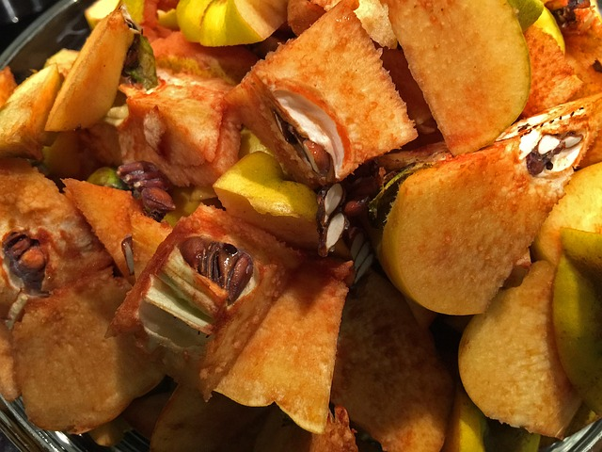

<https://cdn.pixabay.com/photo/2015/11/04/20/16/quince-1023265_640.jpg>

<https://pixabay.com/photos/quince-leftovers-pieces-fruit-fall-1023265/>

DorianKrauss

1. Used batteries from room amenities.
2. Glass bottles from the bar.
3. Old towels discarded by housekeeping.

**Self-Assessment Task:**

**Understanding Waste Categories and Environmental Effects**

1. Name and briefly describe three categories of waste that are commonly produced at Villa Roma Boutique Hotel.
2. List two negative and two positive effects of waste on the environment.

**Conclusion:**

In this module, we have explored what waste is, the various categories it can be classified into, and how it interacts with the environment. Waste, when handled improperly, can cause significant harm to both human health and natural ecosystems. However, by understanding waste categories and managing waste effectively through methods like recycling and composting, we can reduce its negative impact and even derive benefits.

**Module 2: Principles of Waste Management**

**Purpose of the Module:**This module aims to equip you with a basic understanding of waste management principles and concepts. You will learn about the waste hierarchy and how to apply it in practical contexts, focusing on reducing waste generation, reusing, recycling, and proper disposal.

**Learning Outcomes (LOs):**

**LO 2.1:**

**Describe and explain the waste management hierarchy.***Assessment Criteria:* Understanding the hierarchy and explaining how each step works.

**LO 2.2:**

**Respond appropriately to questions about the application of the waste hierarchy.***Assessment Criteria:* Demonstrating understanding by answering questions on applying waste management concepts in various scenarios.

**Content:**

**The Waste Management Hierarchy:**

The waste management hierarchy is a set of steps designed to minimize waste and its environmental impact. It prioritizes reducing waste production, reusing materials, recycling, and finally, safe disposal. Here's a breakdown of the hierarchy:

1. **Avoid:** The best way to manage waste is to avoid generating it in the first place. This can be done by making thoughtful choices about what materials to use and what to buy.

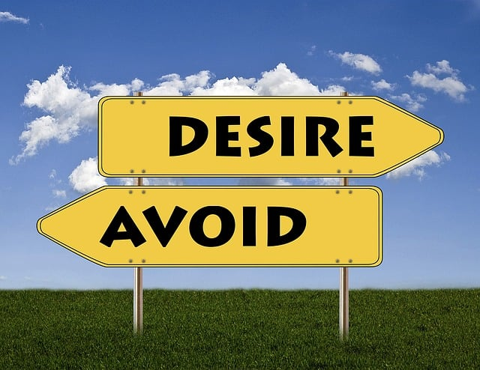

<https://pixabay.com/illustrations/signs-desire-avoid-positive-1172208/>

<https://cdn.pixabay.com/photo/2016/01/31/20/54/signs-1172208_640.jpg>

**johnhain**

1. **Minimise:** Reducing the quantity of waste produced is the next step. This involves using resources more efficiently and finding ways to create less waste.

1. **Separate:** It is crucial to separate different types of waste to ensure that recyclable and recoverable materials are processed appropriately.

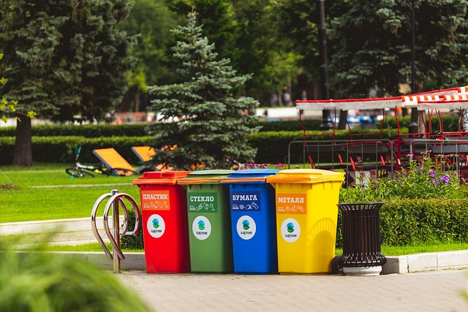

<https://pixabay.com/photos/park-waste-separation-recycling-4337477/>

<https://cdn.pixabay.com/photo/2019/07/14/16/06/park-4337477_1280.jpg>

Vladvictoria

1. **Reuse/Repair:** Items that can be reused should not be discarded. This includes reusing packaging materials or repairing broken items instead of throwing them away.

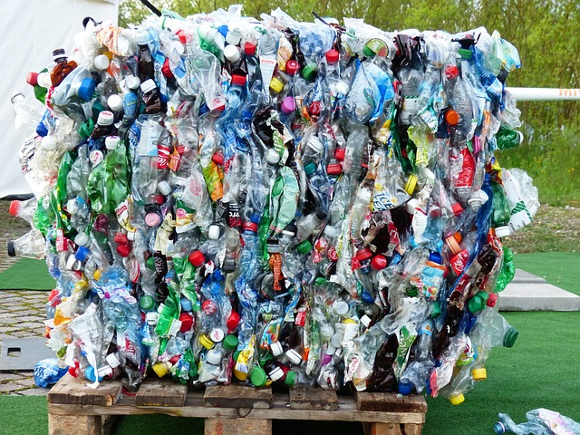

<https://pixabay.com/photos/plastic-bottles-bottles-recycling-115069/>

<https://cdn.pixabay.com/photo/2013/05/31/19/30/plastic-bottles-115069_1280.jpg>

**Hans**

1. **Recycle:** Recycling involves collecting materials that can be processed and turned into new products, like paper, plastics, and metals.

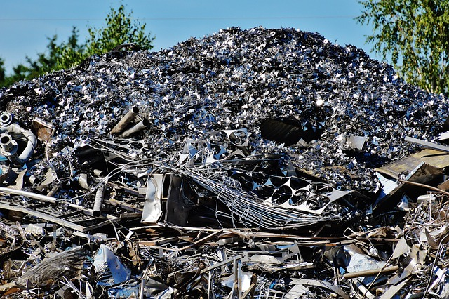

<https://pixabay.com/photos/iron-scrap-metal-thrash-metal-1508237/>

<https://cdn.pixabay.com/photo/2016/07/10/19/10/iron-1508237_640.jpg>

Alexas_Fotos

1. **Treatment/Processing:** Waste that cannot be recycled may undergo treatment to reduce its impact, such as composting biodegradable waste or incinerating non-recyclable items.

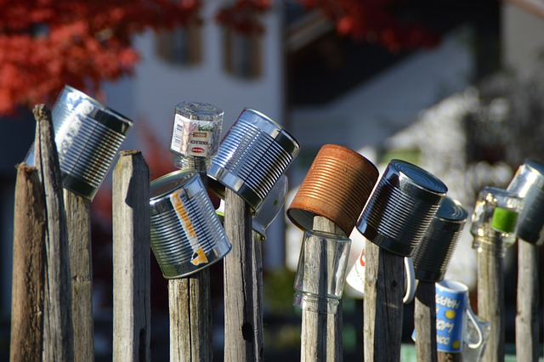

<https://pixabay.com/photos/garbage-waste-separation-recycling-5673549/>

<https://cdn.pixabay.com/photo/2020/10/21/15/42/garbage-5673549_640.jpg>

**aloiswohlfahrt**

1. **Dispose:** As a last resort, waste that cannot be reused, recycled, or treated should be disposed of in a safe and environmentally responsible manner.



<https://pixabay.com/photos/garbage-landfill-truck-dump-truck-5400780/>

<https://cdn.pixabay.com/photo/2020/07/13/13/20/garbage-5400780_640.jpg>

khoinguyenfoto

**Application of the Waste Hierarchy at Villa Roma Boutique Hotel:**

* **Avoiding Waste:** Examples include purchasing items in bulk to reduce packaging waste or switching to reusable guest amenities instead of disposable ones.
* **Minimizing Waste:** Streamlining processes in the kitchen to reduce food waste, for instance, by careful meal planning.
* **Reusing:** Using old towels as cleaning rags or repurposing furniture instead of discarding it.
* **Recycling:** Separating glass, paper, and plastic from general waste for recycling collection.
* **Safe Disposal:** Ensuring hazardous materials like cleaning chemicals are disposed of according to safety guidelines.

**Exercise:**

**Applying the Waste Hierarchy**Based on the waste management hierarchy, how would you manage the following items at Villa Roma Boutique Hotel?

1. Plastic water bottles from guest rooms.
2. Food scraps from the restaurant.
3. Broken electronic equipment.
4. Cleaning chemical containers.

**Self-Assessment Task:**

**Understanding Waste Management Principles**

1. List and briefly explain the seven steps of the waste management hierarchy.
2. Provide an example of how you could apply the waste hierarchy to a specific waste stream (e.g., plastic or food waste) in your workplace.

**Conclusion:**

In this module, you’ve learned about the waste management hierarchy and its significance in reducing the environmental impact of waste. By following the steps outlined—avoid, minimize, separate, reuse, recycle, treat, and dispose—you can ensure waste is handled efficiently and responsibly. Applying these principles in a practical context, such as at Villa Roma Boutique Hotel, will not only reduce waste but also contribute to a healthier, more sustainable environment.

**Module 3: The Waste Management Process**

**Purpose of the Module:**This module will help you understand the sequence of steps involved in the waste management process. You will learn how waste is generated, stored, collected, transported, treated, and disposed of. You will also gain an understanding of waste tracking documentation and its role in ensuring proper waste management.

**Learning Outcomes (LOs):**

**LO 3.1:**

**Identify points where waste is commonly generated.***Assessment Criteria:* Recognize where different types of waste are generated within Villa Roma Boutique Hotel.

**LO 3.2:**

**Describe how waste is stored, collected, and transported.***Assessment Criteria:* Explain safe and effective methods for storing, collecting, and transporting waste.

**LO 3.3:**

**List and describe ways to treat and dispose of waste.***Assessment Criteria:* Identify the various methods of treating (recycling, composting, incineration) and safely disposing of waste.

**LO 3.4:**

**Respond appropriately to questions about the purpose of waste tracking documentation.***Assessment Criteria:* Understand and explain how waste tracking documents help in monitoring and managing waste streams.

**LO 3.5:**

**Carry out waste management safely, with care for the environment and well-being.***Assessment Criteria:* Demonstrate the ability to handle and manage waste safely, ensuring environmental protection and the health of hotel staff and guests.

**Content:**

**The Waste Management Process:**

The waste management process involves several key steps that ensure waste is handled effectively and safely. Understanding these steps is crucial for maintaining a clean and sustainable environment in a hospitality setting.

1. **Generation:**Waste is generated at various points in the hotel, such as:
   * **Guest Rooms:** Paper, plastic, food packaging.
   * **Kitchen/Restaurant:** Food scraps, cooking oils, packaging.
   * **Housekeeping:** Used linens, cleaning chemical containers.
   * **Maintenance:** Electronic waste, broken furniture.
2. **Storage:**Waste should be stored safely and in a manner that avoids contamination or hazards:
   * **General Waste:** Stored in designated bins to prevent odors and pests.
   * **Hazardous Waste:** Stored separately in clearly marked containers.
   * **Recyclables:** Sorted by material (plastic, paper, glass) and stored in recycling bins.
3. **Collection and Transport:**Waste collection should be performed regularly to prevent accumulation. Proper transportation ensures waste is moved to treatment or disposal sites without causing spillage or contamination.
   * **General Waste and Recyclables:** Collected by waste service providers or municipal authorities.
   * **Hazardous Waste:** Collected by certified hazardous waste handlers with appropriate safety measures.
4. **Treatment:**Different types of waste undergo specific treatment processes:
   * **Recycling:** Materials such as glass, metal, and plastic are collected and processed into new products.
   * **Composting:** Organic waste (like food scraps) is broken down naturally to create compost.
   * **Incineration:** Some waste, such as medical or hazardous waste, may need to be incinerated to prevent harm.
5. **Disposal:**Waste that cannot be reused, recycled, or treated is disposed of in landfills or other safe disposal sites. Safe disposal ensures the least harm to the environment.
6. **Waste Tracking Documentation:**Waste tracking involves documenting the types and quantities of waste generated and its disposal methods. This helps ensure compliance with legal regulations and demonstrates environmental responsibility. Tracking may include:
   * Records of waste collection and disposal.
   * Receipts from waste service providers.
   * Documentation of hazardous waste management.

**Exercise:**

**Mapping the Waste Management Process**For each of the following areas in Villa Roma Boutique Hotel, identify a common type of waste generated and outline the steps of the waste management process for handling it (generation, storage, collection, transport, treatment/disposal):

1. Guest rooms
2. Kitchen/Restaurant
3. Maintenance department

**Self-Assessment Task:**

**Understanding the Waste Management Process**

1. Explain the six steps in the waste management process.
2. How should hazardous waste be stored and disposed of in the hotel setting?
3. What is the purpose of waste tracking documentation, and how does it benefit the hotel?

**Conclusion:**

This module covered the key stages in the waste management process, from the generation of waste to its final disposal. By understanding where waste is generated, how it should be stored and transported, and the methods used to treat and dispose of it, you will be able to ensure that waste is managed efficiently and safely at Villa Roma Boutique Hotel. Waste tracking documentation is a crucial part of this process, as it helps monitor and improve waste management practices. Ensuring all steps are followed correctly will contribute to environmental sustainability and the well-being of both staff and guests.

**Module 4: Recognizing and Responding to Special Waste**

**Purpose of the Module:**This module will help you understand the types of special waste, including hazardous, electronic, and healthcare waste, and the appropriate procedures for handling, storing, and disposing of them. You will also learn how to respond to emergencies related to special waste in a safe and compliant manner.

**Learning Outcomes (LOs):**

**LO 4.1:**

**Identify examples of special classes of waste.***Assessment Criteria:* Recognize different types of special waste generated within the hotel.

**LO 4.2:**

**Respond to questions about recognizing and identifying special classes of waste.***Assessment Criteria:* Show an understanding of how to identify and classify special waste, such as hazardous and electronic waste.

**LO 4.3:**

**Take appropriate actions in response to each class of special waste.***Assessment Criteria:* Demonstrate knowledge of safe handling, isolation, reporting, and emergency procedures for special waste.

**Content:**

**What is Special Waste?**

Special waste refers to waste that requires specific handling due to its potential to harm human health, animals, or the environment. Special waste includes items that are flammable, toxic, reactive, or infectious, and must be managed differently than general waste.

**Types of Special Waste:**

1. **Hazardous Waste:**This includes chemicals, paints, cleaning agents, and other materials that can pose a risk to health or the environment.
   * **Examples:** Cleaning chemicals, solvents, pesticides.
2. **Electronic Waste (E-Waste):**Discarded electronic items, such as computers, cell phones, and televisions. E-waste contains hazardous substances like lead, mercury, and cadmium that require special disposal.
   * **Examples:** Broken laptops, used batteries, light bulbs.
3. **Healthcare Generic Waste:**Waste generated from healthcare activities that is not hazardous but still requires special attention, such as bandages and personal protective equipment (PPE).
   * **Examples:** Face masks, gloves, non-infectious medical materials.
4. **Healthcare Risk Waste (Medical Waste):**Waste generated from healthcare that poses a risk to human health or the environment, including sharps, biological waste, or materials contaminated with infectious agents.
   * **Examples:** Used needles, syringes, blood-stained materials.
5. **Radioactive Waste:**Rare in most hotels but includes materials contaminated with radioactive substances. These require special isolation and disposal methods.
   * **Examples:** Certain medical devices.

**Responding to Special Waste:**

1. **Proper Storage:**
   * **Hazardous Waste:** Stored in clearly labeled, leak-proof containers, away from general waste.
   * **E-Waste:** Stored in designated e-waste collection points.
   * **Healthcare Waste:** Isolated in sealed, clearly marked biohazard containers.
2. **Emergency Procedures:**In case of spills or leaks involving hazardous or healthcare waste:
   * Evacuate the area if necessary.
   * Wear protective equipment (gloves, masks) before handling the waste.
   * Report the incident to a supervisor immediately.
   * Follow the hotel’s emergency protocol for hazardous waste containment and cleanup.
3. **Reporting:**Special waste must be reported to ensure proper handling. All incidents or improper disposal of hazardous or healthcare waste should be documented.  
   **Key Points:**
   * Record the type of waste.
   * Note how it was generated and handled.
   * Ensure waste collection is completed by certified waste handlers.

**Exercise:**

**Handling Special Waste at Villa Roma Boutique Hotel**Identify the correct procedures for handling the following types of special waste generated in the hotel:

1. A used battery from a guest’s laptop.
2. A broken light bulb from the hallway.
3. A spill of cleaning chemicals in the housekeeping area.
4. A needle discarded in a bathroom by a guest.

**Self-Assessment Task:**

**Recognizing and Responding to Special Waste**

1. Name and describe four types of special waste that may be generated in a hotel.
2. How should healthcare risk waste, such as used needles, be handled and disposed of safely?
3. What actions would you take if there were a chemical spill in the hotel?

**Conclusion:**

In this module, you have learned about the different types of special waste, such as hazardous, electronic, and healthcare waste, and how to recognize and respond to them appropriately. Proper handling, storage, and reporting of special waste is crucial to ensuring the safety of both staff and guests at Villa Roma Boutique Hotel. By following established procedures, such as emergency protocols for chemical spills and using the correct containers for hazardous waste, you can help prevent accidents and environmental damage.

**Module 5: Applying Waste Management Principles and Procedures in Your Own Context**

**Purpose of the Module:**This module focuses on the practical application of waste management principles and procedures. You will learn how to minimize, reuse, recycle, and dispose of waste effectively in your specific work environment, community, or home. By the end of the module, you will be able to investigate a waste stream familiar to you and demonstrate practical ways of managing it sustainably.

**Learning Outcomes (LOs):**

**LO 5.1:**

**Collect and dispose of a variety of environmentally sensitive materials according to type.***Assessment Criteria:* Demonstrate proper handling, segregation, and disposal of different types of waste.

**LO 5.2:**

**List and describe ways to reduce the amount of waste generated.***Assessment Criteria:* Provide practical examples of minimizing waste in the workplace.

**LO 5.3:**

**Identify waste that can be reused and describe ways to reuse it in your context.***Assessment Criteria:* Recognize reusable waste and propose ways to incorporate reuse into daily operations.

**LO 5.4:**

**Respond appropriately to questions about ‘what’ and ‘why’ regarding waste management choices.***Assessment Criteria:* Show the ability to explain your decisions regarding waste minimization, reuse, and recycling.

**Content:**

**Minimizing Waste:**

Minimizing waste means reducing the amount of waste produced in the first place. This can be achieved by making careful purchasing decisions, reducing consumption, and optimizing resource use.  
**Examples of Waste Minimization at Villa Roma Boutique Hotel:**

* **Kitchen:** Implement portion control to reduce food waste.
* **Guest Rooms:** Offer refillable toiletries instead of single-use bottles.
* **Office:** Switch to digital documents to reduce paper waste.

**Reusing Materials:**

Reusing materials extends the life cycle of products, preventing them from becoming waste. Reuse requires creativity and a focus on repurposing items that would otherwise be discarded.  
**Examples of Reusing Waste:**

* **Linens:** Repurpose worn towels or linens as cleaning rags.
* **Packaging:** Reuse cardboard boxes for storage or supplies.
* **Furniture:** Repair damaged furniture instead of discarding it.

**Recycling:**

Recycling transforms waste materials into new products, conserving resources and reducing the environmental impact. Waste materials such as paper, glass, plastic, and metal can be processed and used again.  
**Examples of Recycling at the Hotel:**

* Collect used bottles and plastic from guest rooms and the restaurant for recycling.
* Set up designated recycling bins in common areas and staff rooms.
* Partner with local recycling programs to ensure proper disposal.

**Handling and Disposal:**

Waste that cannot be minimized, reused, or recycled should be handled and disposed of responsibly. Proper disposal ensures that waste does not harm the environment or public health.  
**Disposal Practices at Villa Roma Boutique Hotel:**

* **General Waste:** Collected by local waste disposal services and sent to a landfill.
* **Hazardous Waste:** Stored in appropriate containers and collected by certified waste handlers.
* **Composting:** Organic waste, such as food scraps, can be collected for composting to reduce landfill waste.

**Investigating a Waste Stream:**

To apply waste management principles in your own context, you must first investigate a specific waste stream. For example, you could focus on:

* **Food waste** in the hotel kitchen and ways to reduce and compost it.
* **Paper waste** from office operations and steps to minimize and recycle it.
* **Plastic waste** from guest services and initiatives to reuse or eliminate single-use plastics.

**Exercise:**

**Practical Waste Management Solutions**Identify a waste stream in your department at Villa Roma Boutique Hotel. Describe how you would apply the following waste management principles to it:

1. Minimize
2. Reuse
3. Recycle
4. Dispose

**Self-Assessment Task:**

**Applying Waste Management in Your Context**

1. List three ways to reduce waste in your work environment.
2. Identify one type of waste in your department that could be reused and describe how it could be repurposed.
3. Explain how you would ensure that recyclable materials are properly collected and processed at the hotel.
4. Why is it important to focus on reducing waste rather than just disposing of it?

**Conclusion:**

In this module, you have learned how to apply waste management principles—minimizing, reusing, recycling, and disposing—in your work or community context. By actively identifying opportunities to reduce waste, repurpose materials, and recycle whenever possible, you contribute to a more sustainable environment. Practical application of these principles at Villa Roma Boutique Hotel helps the hotel operate more efficiently, reduces costs, and enhances its environmental responsibility. As you continue to apply these practices, you'll see positive changes in both waste reduction and the overall sustainability of the hotel.

**Wrap-Up: Handle and Dispose of Waste at Villa Roma Boutique Hotel**

This training manual has provided a comprehensive guide to effectively managing waste in the hospitality environment of Villa Roma Boutique Hotel. By understanding the different categories of waste, the principles of waste management, and the practical steps involved in handling and disposing of waste, you are now equipped with the knowledge to perform your job more efficiently and with care for the environment.

Throughout this manual, we’ve emphasized the importance of:

* **Understanding waste** and its impact on the environment (Module 1).
* **Applying the waste management hierarchy**, which prioritizes avoiding, minimizing, reusing, and recycling waste before considering disposal (Module 2).
* **Following the waste management process**, including generation, storage, collection, treatment, and disposal of waste (Module 3).
* **Handling special waste** like hazardous, electronic, and healthcare waste with appropriate safety measures (Module 4).
* **Applying waste management principles** in your specific context by minimizing, reusing, recycling, and safely disposing of waste (Module 5).

By mastering these concepts and procedures, you not only contribute to the smooth operation of the hotel but also help reduce its environmental footprint. Waste management isn’t just a legal or operational requirement—it’s part of our responsibility to protect the environment and ensure a safe, healthy workplace for all staff and guests.

Remember, the choices we make today will affect tomorrow’s environment. Whether it’s minimizing food waste in the kitchen or ensuring that hazardous materials are disposed of properly, every action you take contributes to a more sustainable future. Continue applying these principles daily, and strive to improve Villa Roma Boutique Hotel’s waste management practices through innovation, efficiency, and responsibility.

Thank you for your commitment to waste management, and for being a crucial part of Villa Roma Boutique Hotel’s journey toward sustainability!

[**https://pixabay.com/photos/apples-fallen-apples-rot-compost-7557408/**](https://pixabay.com/photos/apples-fallen-apples-rot-compost-7557408/)

<https://cdn.pixabay.com/photo/2017/08/05/23/27/newspapers-2586621_640.jpg>

<https://pixabay.com/photos/pollution-toxic-products-environment-3075857/>

<https://pixabay.com/photos/fruit-orange-citrus-waste-dump-5030091/>

<https://cdn.pixabay.com/photo/2014/04/25/16/04/garbage-331929_640.jpg>

<https://cdn.pixabay.com/photo/2024/06/01/13/37/pollution-8802271_640.jpg>

<https://pixabay.com/vectors/wall-destruction-stones-castle-7112476/>

<https://pixabay.com/illustrations/ai-generated-hedgehog-beaver-8741013/>